Wiring and Testing the LED
Wiring
Start by wiring the LED to the Arduino as shown in the schematic below. Make sure you include the 330 Ω resistor in series with the LED to prevent it from being damaged by current. Note that the LED has a long and short leg, and make sure you have it oriented as shown in the image. While it’s not shown in the schematic below, you should not remove the circuitry you created in the previous section where you wired in the light sensor.
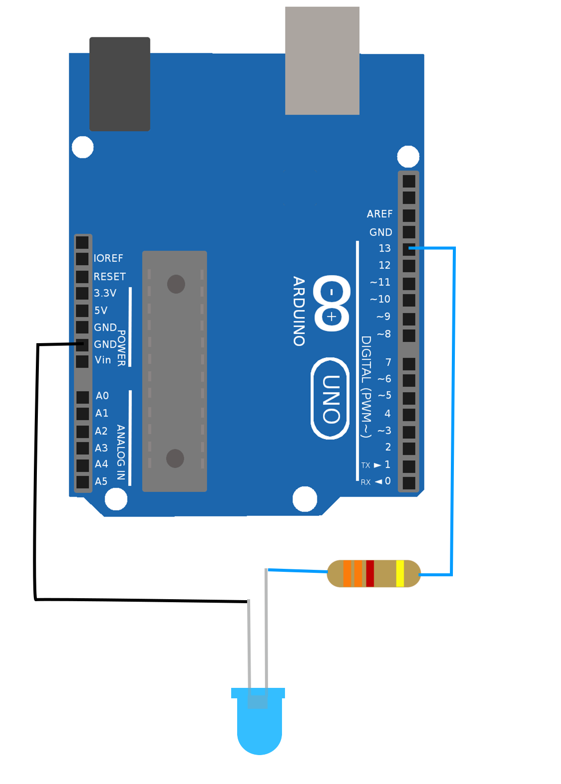

Keep in mind, this image is a schematic. Your implementation of this schematic will use the breadboard and so the wires will not all connect directly to the Arduino.

Testing
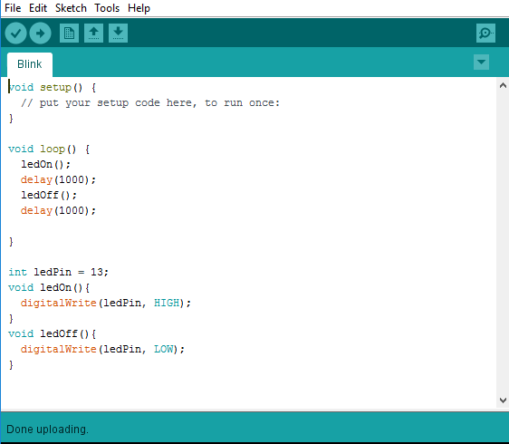
Once you have the wiring in place, open and upload the included sketch ‘Blink.

Unlike previous sketches, this one will not create any output to the serial monitor. Instead, you should see your LED toggle between on and off every second. If you don’t see this, you may need to check your wiring (pay special attention to the polarity of the LED).

Code Walkthrough

void setup() {
// put your setup code here, to run once:
}

The setup function in this particular sketch doesn’t actually do anything, but we still have to include it or the code will not compile.
void loop() {
ledOn();
delay(1000);
ledOff();
delay(1000);
}

The main program loop turns the LED on, then waits 1 second, then turns the LED off. Since this is repeated forever, this program blinks the LED on for 1 second and off for 1 second forever.

int ledPin = 13;
void ledOn(){
digitalWrite(ledPin, HIGH);
}
void ledOff(){
digitalWrite(ledPin, LOW);
}
Here we have a block of code where we first instantiate a new variable that defines to which pin the LED is attached. The next two functions turn the LED on and off respectively using the digitalWrite function and setting that pin to either HIGH (on) or LOW(off).

